Welcome to Leitrim

Welcome to Leitrim

Leitrim
A small rural county in the northern part of Ireland. Based on the population of the 32 counties, Leitrim is the least populated place. The county's main town is Carrick on Shannon .
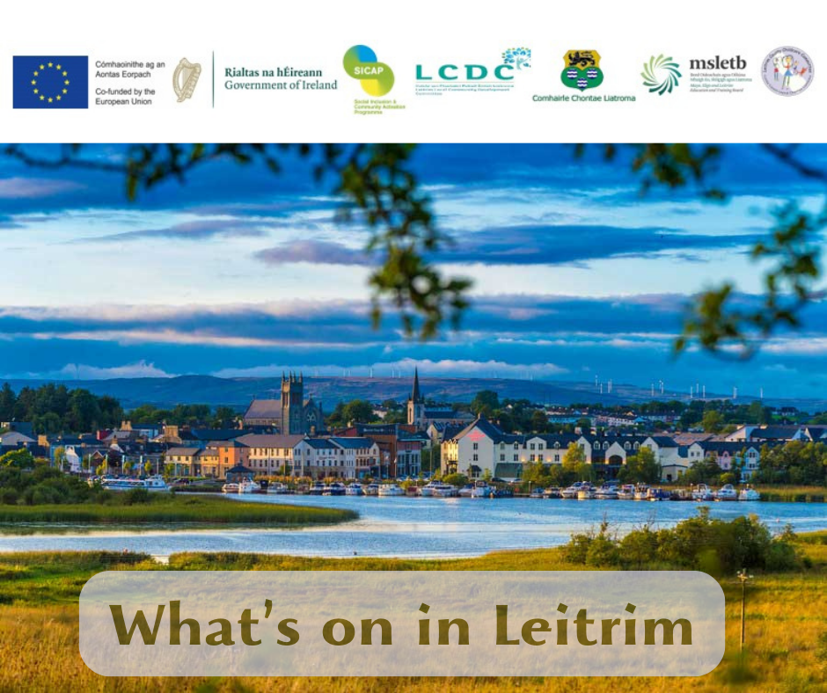
Other small towns are Ballinamore, Drumshanbo, Kinlough, Manorhamilton, Mohill. County Leitrim is renowned for its scenic beauty, particularly its lakes, rivers and waterfalls.

Leitrim Development Company
It is a local, community-led development company with its head office in Drumshanbo.
We support communities, individuals and businesses to increase their economic resilience and improve their quality of life.
The Social Inclusion and Community Engagement Program SICAP, which helps both individuals and groups through a two-pronged approach; supporting communities and supporting individuals.
Natalia Belyakova is a Ukrainian social worker providing consultation and individual assistance or advice on support issues such as health, social security, housing, relocation, study, education, employment, organizing children's camps. Please contact Natalia on Telegram @NatashaLDCO , number 0860758589 or nataliya@Ldco.ie
Also, to help employees as a Ukrainian Support worker, Erika Yushchenko works at LDCO , Telegram @eri4kaYu . You can contact her by phone: 0861526796, erika@ldco.ie

Temporary protection and PPSN

Temporary protection letter about temporary _ _ protection e
When you arrive in Ireland, you will first need to obtain a Temporary Protection Letter from Citywest Convention Centre, Saggart , Co. Dublin , D24 A38Y. For detailed information you can send an e-mail to ukrainesupportmailbox@justice.ie.
From January 4, 2024, the validity of a residence permit in Ireland ( Residence Permit ) on the basis of Temporary Protection has been extended until March 4, 2025. This means that your leave to remain is automatically renewed and you do not need to apply for an extension and you have the legal right to reside in Ireland even if you do not renew your TPC or IRP. For questions regarding continued status, please contact temporaryprotection@justice.ie.
IRP or Irish Residence A permit card is a document in the form of a plastic card confirming that you are legally in Ireland. If you have not yet received a card, this may be a signal that your data has been lost or there has been a failure in the system. If this is the case, please email tpregistration@justice.ie and ask if there is anything needed from you to receive the card. Please attach photocopies of your passport, Temporary Protection Letter and proof of address ( accommodation) to your letter letter ).

for renouncing temporary status protection
If you decide to leave Ireland and refuse temporary protection. The procedure for renouncing status provides two options:
- Submitting an application in person at one of the centers:
Citywest Convention Centre, Saggart , Co. Dublin, D24 A38Y
Cork City PSC and PPSN Centre, Ground Floor, Hanover Street, Cork, T12 PX62
Limerick Intreo Centre, Dominick Street, Limerick, V94 X327
- Online by sending a request to ukrainesupportmailbox@justice.ie
In your application, please indicate that you wish to waive temporary protection in Ireland and attach your details:
- last name and first name,
- Date of Birth,
- PPSN
- residential address,
- TP number.
Original document from the Department of Justice about Temporary Protection ( yellow paper on temporary protection) should be sent by mail to:
Citywest Convention Centre,
Garter Ln, Saggart ,
Co Dublin, D24 A38Y
For more information, visit the Department of Justice's Immigration Services Division website.
https://www.irishimmigration.ie/ru/faqs-for-ukraine-nationals-and-residents-of-ukraine/

PPS Number / PPS Number
Already directly in City West, or in one of the INTREO departments at your place of residence, you need to obtain an Irish identification number - PPS (Irish social security number ). This is necessary in order to access services, healthcare and employment. All adults and children need a PPS number. Adults over 18 years of age are also required to obtain a PPSN card from INTREO.
INTREO's local office in County Leitrim is located in Carrick-on- Shannon and Manorhamilton:
Manorhamilton Intreo Center
Sligo Road, Manorhamilton F 91 AD90
manorhamilton@welfare.ie 0818 405060
Carrick-on-Shannon Intreo Center
Leitrim Road, Carrick-on-Shannon, N41 CY83
carrickonshannon @ welfare . ie 0818 405060

INTREO - Welfare

Material aid
You can apply for financial assistance by contacting your local Intreo center .
There are several main types of benefits available to Ukrainians for which different forms are filled out:
1. Jobseeker Allowance
A. Age from 25–66 years
b. Adult dependent supplement
V. Dependent child allowance
d. Age 18–24 years old, lives independently*
d. Age 18–24 years, does not live independently.
The table is attached below:
2. Single-parent family / One Parent Family (includes benefits above A + B)
3. Disability ( same calculation as for job applicants)
4. State pension/State Pension Non-Contributory
Age 66–80 years €266
Age 80+ years €276
Supplement for adult dependent up to 66 years €175.70
Supplement for dependent child according to the table.
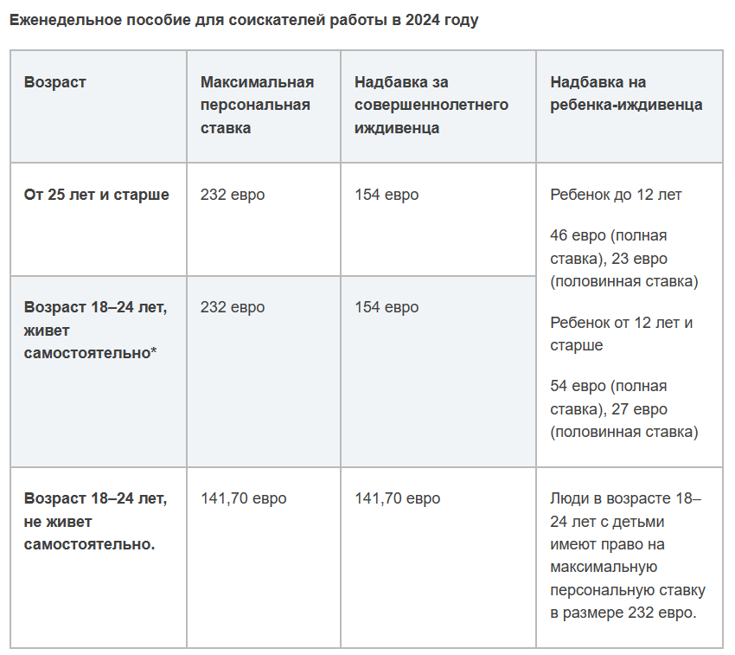

Social benefits for Ukrainians who left for Ireland after 01/29/2024.
New arrivals from Ukraine who use government-provided housing will receive 38.80 euros per week under new plans approved by the Cabinet.
There will also be a new 90-day limit on residential accommodation for new arrivals.
The reduced benefit will be paid over a 90-day period with an additional payment of €29.80 per child per week.
After 90 days, if they are unemployed, their Social Security benefits will be recalculated.
Everyone will be entitled to health cards and children will be entitled to Child Benefit Benefit .

Child Benefit _ _
Child support is paid to parents or guardians for each child under 16 years of age (for children from 16 to 18 years of age if they are full-time students or have a disability that does not allows them to support themselves). The assistance for each child is 140 euros per month.

Receiving a Social Security Payment
If you are entitled to social assistance and/or child benefit, after completing the form in INTREO, the benefit will be paid at your post office. To do this you will need in the mail:
a) your PPS/PPSN card number.
b) photo ID, e.g. your passport, driver's license or national ID (expired documents are also accepted)
Additional information in Ukrainian about social security can be obtained on the web page:
gov.ie - Help with receiving social security for those coming from Ukraine under the EU Temporary Protection Directive (www.gov.ie)

Health _ _

Medical Card
Anyone arriving in Ireland under the Temporary Protection Directive is entitled to a health card. A health card allows you to visit a doctor free of charge, receive other medical services, and receive free prescription medications. It also covers government outpatient and inpatient services, vision and hearing tests, and some dental services.
Children over 16 years of age must obtain a medical card separately.
For citizens of Ukraine, you must apply for a medical card using a special form:
https://www2.hse.ie/services/healthcare-in-ireland/rus-medical-card-application-form.pdf
The completed form can be emailed to PCRS.Applications@HSE.ie or at the address specified in the form.
have completed the form , you can visit the Family Doctor (GP) in your area and have them stamp the form to register you as their patient.
(If a doctor is not found, the HSE will appoint you, in which case leave the space on the form blank for the GP stamp.)
For questions regarding medical records, obtaining a GP, transport assistance from hard-to-reach areas to hospital, etc., please contact Afrique Gray, Leitrim Development HSE Officer on 0719641770.

Prescription medicine
If you need a prescription before you receive your medical card, you can take your prescription or container to your local pharmacy and they will give you a month's supply.
If you need to get an analogue of a medicine that a patient in Ukraine took on an ongoing basis due to a chronic disease, you need to contact a doctor - this could be a doctor at a hotel, a doctor at a free clinic (including by phone), or a GP family doctor.
If this is not possible, and you need the drug urgently, you can try asking for a local analogue of your usual drug for free at the nearest pharmacy for 5 days according to these instructions. Important: this is an instruction for those who have taken any drug in Ukraine on an ongoing basis; it is NOT SUITABLE for acute cases.
How to find the Irish equivalent of your medicine:
You open the instructions for your medicine and look for the name of the active substance, often it is indicated immediately in Latin, if not, we translate it into English in a translator. For example: Eutirox medicines have the active ingredient levothyroxine sodium or Levothyroxine sodium _
This should be enough for the pharmacist/GP to find Irish equivalents in their database. For reinsurance, you can find analogues yourself:
Go to the website https://www.hpra.ie/ and enter the active ingredient in English into the search.

Emergency numbers Number
In life-threatening emergencies, call 999 or 112 for an ambulance. Or numbers free e for calls :
Local Health Centers
Ballinamore (071) 964 4353
Carrick-on-Shannon (071) 965 0300
Carrigallen (049) 433 9797
Dromahair (071) 916 4215
Dromod (071) 965 8702
Drumkeerin (071) 964 8043
Drumshanbo (071) 964 1105
Glenfarne (071) 985 3229
Kiltyclogher (071) 985 4071
Kinlough (071) 984 3013
Manorhamilton (071) 985 5788
Mohill (071) 963 1900
Newtowngore (049) 433 9009

Medical service out of office time
If you need to contact a GP outside of clinic opening hours (usually 09:00 to 17:00 Monday to Friday), you can contact the out-of-hours service in your area. This service does not include regular clinic appointments. You must make an appointment by phone in advance. If your medical problem is not urgent, you should make an appointment with your GP during normal clinic opening hours.
NOW Doc
Inver Geal, Cortober , Carrick on Shannon
0818 400 911

Care Doc
Barrack Street, Rathquarter , Sligo
0818 365 399

Medicines in Ireland that can be bought without a prescription:
1. For colds - Lemsip
2. Cystitis - Cystopurin
3. Heaviness in the stomach - Gaviscon
4. Disorder (diarrhea) - IMODIUM
5. Constipation - Senokot
6. Ointment for hemorrhoids - Anusol Cream
7. Painkillers - Nurofen , available for both adults and children.
8. Pain in the joints, lower back, neck - warming and pain-relieving ointments, patches - Deep Heat
9. Stomach upset, headache - Alka-Seltzer
10. Drops from pain V ear - Cl-ear Pain Relief Ear Drops
11. Plug in the ear - Exterol for adults and children
12. Nasal drops for adults - Otrivine Adult Nasal Drops
13. Nasal drops for children - Calpol Saline Nasal Drops
14. Dry cough - Benylin Non- Drowsy Dry Cough Syrup , available for both adults and children.
15. Dry cough and stuffy nose - Strepsils
16. Wet cough - Benylin Wet Cough Menthol Mucus Relief , available for both adults and children.
16. Sore throat, spray - Difflam Spray
17. For sleep - Kalms Night
18. For kids. Calpol - Antipyretic, headache, toothache, earache, teething, sore throat, colds and flu
19. Sedatives - ( like valerian) Bach Rescue Remedy
20. For calm sleep - Bach Rescue Night Dropper.
21. Chickenpox - we don’t go to the hospital! We buy V pharmacy - PoxClin CoolMousse for children with chickenpox
22. Lice (lice). Without panic we buy at Tesco - Hedrin All In One Shampoo or V Pharmacy Full Marks Solution 5 Minute Treatment.
23. For babies when they are teething, and for adults if a tooth hurts or a wisdom tooth is coming out, supergel - Bonjela Soothing Teething Gel .
24. Conjunctivitis - Brolene Eye Drops
25.Cetrine - allergies
26.Canestan - Candidiasis
27.Voltarol - diclafonek gel
28.Sudocreme - chickenpox
29.Benzydamine Spray - Sore throat
30.Activated Charcoal - activated carbon
31. Disprin - aspirin
32. Iodine - iodine

Additional links
https://www2.hse.ie/services/healthcare-in-ireland/ukrainian-refugees.html

Dental on Medical Cards

Access to dental care for people with a Sligo and Leitrim health card
Adults (>16 years of age) who have health cards are entitled to access dental care in dental practices according to the Dental Treatment Scheme ( DTSS) ). In recent years, a significant number of dental practices nationally and locally have withdrawn from the scheme, resulting in problems with access. The scheme was adjusted on 1 May 2022, so this situation may improve.
Because of these problems, the HSE dental service has had to step in and provide emergency care to adults without access to the scheme. Some routine care is also provided, but there is a waiting list. Here is a link to the treatment that is provided under DTSS . There are no DTSS dentists in Leitrim and only one in North Sligo.
Dental Services - HSE.ie
Emergency/urgent dental care is generally defined as the treatment of pain, infection, swelling, injury or bleeding due to dental causes.

Adults with special needs have the highest priority in accessing assistance, although there are still waiting periods. If someone of Ukrainian origin has special needs and requires access to routine medical care, it is important that this information is known at the time of seeking treatment.
To access routine medical care for adult medical card holders, the following options are available:
1. Make an appointment with a practice that is accepting new DTSS patients. As far as I know the only ones in or near Sligo and Leitrim who undertake this are:
Grange Dental Practice 071 9163774
Longford Dental Center 043 3336654
Dr Tom Boland , Boyle 071 9662432
They have limited capacity , so can usually only offer meetings occasionally. It is entirely possible that with changes to the scheme, other practices may be able to welcome new patients again.
2. As mentioned earlier, we have a contractor who provides services at the Markevich House, for whom there is a waiting list. Sheila Lundy looks after this and can be contacted at Sheila.Lundy@hse.ie or 071 9321051.

Routine dental care for children.
Children are called from school for planned treatment only from the 6th grade or 12 years old, and there is a waiting list for this. You can also contact the HSE Dental Practice at Townparks, Carrick-On-Shannon, Co. Leitrim , N 41 E 3 C 9
(071) 932 1400

Education - Primary and Secondary School

For children
To enroll children in your local primary (approximately 4–12 years) or senior (approximately 13–18 years) school, you can contact your local headteacher; or contact Tusla Educational Support to help you find a school for your children.
Due to insufficient places for children in schools in Carrick on Shannon , Drumshanbo, Leitrim Village etc., to help you find your nearest place please complete the school ETB form :
https://forms.office.com/e/cNEAJ4R34d
Educational Welfare Service, Tusla Educational Support Service,
Teresa Barrett : Tel : 091-385302

School uniform:
The School Clothes and Shoes Grant is a payment that can help cover the cost of school uniforms and shoes for children going to school.
BSCFA is paid automatically to many families. If you are paid automatically, you do not need to apply for BSCFA.
If you haven't received your automatic payment, you can apply for a payout on MyWelfare .
To receive the school clothing and footwear allowance, your child must:
Between 4 and 17 years of age as of September 30 of the year in which you apply for the BSCFA.
You are between 18 and 22 years old and returning to full-time second level education at a recognized school or college in the autumn of the year you apply for the BSCFA.
You cannot claim BSCFA for a child who is not resident in Ireland.
Refer to the section “Allowance for school clothes and shoes”:

Department of Social Protection
Back to School Clothing and Footwear Allowance Review Section
Social Welfare Services
Department of Social Protection
College Road
Sligo
F91 T384

Tel: 071 919 3318 or 0818 111 113
Homepage: https://www.gov.ie/en/service/41eb8b-back-to-school-clothing-and-footwear-allowance/
Email : BSCFA @ welfare . ie

or
A welfare officer can help you with school uniform costs. Call the Intreo Center in Carrick on Shannon on 07196–50070.

School transport:
In order for your children to benefit from free transport to and from school, the family/host family must register using the link below and then provide details for each student
New Ukrainian Child School Transport Request form FlowForma

Childcare

Kindergartens
There is an Early Childhood Care and Education Program ( Early Childhood Care and Education Scheme - ECCE ). The program is available to children who turned 2 years and 8 months before September 1. Children can continue in the program until they enter primary school if they are no more than 5 years and 6 months old by the end of the preschool year on 30 June.
Kindergarten services under the free ECCE scheme are 3 hours per day for 5 days a week. If your child attends more than this time each day, you will be charged for the extra time or you can apply for an NCS subsidy :
https :// www . ncs . gov . ie / en /
If your child does not attend kindergarten for 4 weeks in a row, you may lose your place. For example, in case of long-term illness, the place can be kept for up to 12 weeks. In the event of the loss of a loved one, a place can be held for up to 6 weeks.
More information at the link: https :// www . citizensinformation . ie / en / education / pre - school - education - and - childcare / early - childhood - care - and - education - scheme /

Care for Children
County Leitrim Childcare Committee offers support and information to enable families to access childcare in the county, as well as support for childcare services.
Contact us by email: info @ leitrimchildcare . ie or by phone 0719640870

Adult Education & Training

Additional education
Leitrim Development is working with Mayo, Sligo and Leitrim Education and Training Board to deliver a range of courses across the county. Not all courses provided are intended for employment, but can be a building block for access to more formal educational opportunities. Priority is given to persons who have left the education system with little or no qualifications, and to persons who have received less benefit by participating in the formal education system :
- Information, advice and guidance regarding education, training and careers
- Information about courses and the application process
- Recognition of qualifications
- Funding and support for education

Local courses, free for recipients and full-time scholarship recipients , are run by Mayo, Sligo and Leitrim Education and Training Board and include:
- Courses after graduation training / Post Leaving Certificate (PLC) Courses
- Scheme opportunities professional training / Vocational Training Opportunities Scheme (VTOS)
- Back to Education Initiative ( BTEI)
- Adult Literacy _ _
- Community Education _
Courses are held at various training centers and community venues throughout County Leitrim : Home - FET Course Hub ( fetchcourses.ie ) _ _

For support and advice on education and youth issues, please contact Jeanette Leyden, Education and Youth Services Officer at Leitrim Development, on 07196–41770 ext. 210, or email jeanette@ldco.ie

English courses a
All English classes are provided by MSLETB - County Leitrim Education and Training Board. For more information about upcoming English courses, contact Naomi Spelman on 0860455013
Or by contacting Martina OSullivan 0719621371 / 086 774 3329 martinaosullivan@msletb.ie

Spoken English
Leitrim Development also provides spoken English lessons for one to two hours per week. Contact Caillin on 0857653152 caillin@ldco.ie or Debra Sherlow deborah@ldco.ie 0861532776 and come along to one of our classes.

Other training
Leitrim Development can provide a range of accredited business courses throughout the year. Below is a list of some of the courses provided;
- Manual Handling Course (1/2 day )
- Safety Awareness in the Workplace (1/2 day)
- Safe Pass
- Computer (Basic/Advanced) Training
Other courses can be provided upon request to help people find work or improve their employability. This bespoke service is tailored to the needs of each individual client and the local environment in which they operate.
For support and advice regarding training and education, please contact Michael Bruen, Training and Enterprise Support Specialist at Leitrim Development, on 07196–41770 ext. 209, or email mbruen@ldco.ie

Employment _ _

Local Job Listings
You have the right to work in Ireland if you have a letter of authorization which confirms that you have been granted temporary protection under the EU Directive
For the latest weekly job information in County Leitrim, visit www.facebook.com/leitrimjobclub to view the latest week's news - leitrim jobs bulletin

Top job search sites in Ireland
https://www.jobs.ie
https://jobsireland.ie
https://ie.indeed.com
https://www.irishjobs.ie
https://www.linkedin.com
https://www.monster.ie
https://ie.jooble.org
https://publicjobs.ie/en/
https://www.jobalert.ie
https://www.studentjob.ie

Writing a resume
For help with CV writing and job interview skills, contact the SICAP team in Leitrim Development Company , contact Erika Yushchenko 0861526796, erika@ldco.ie

Help in finding self-employment opportunities.
Leitrim Development Company (LDC) can provide support and guidance to people who are interested in starting their own business. These include:
- One-on-one mentorship and advice to help you turn your idea into a sustainable business.
- Business planning and development.
- Advice on legal obligations when starting your own business.
- Information about financing available to start a business and expand your business.
- Start your own business courses and other business related training.
- Help V submission applications on Back to Work Enterprise Allowance. LDC is partnering with Intreo to implement the Back to Work Enterprise Allowance program.

For information on how to start your own business, please contact Lum O'Brien, Leitrim Development Company Business Support Officer, at liam@ldco.ie or by phone 071–9641770, ext.206.

Government employment schemes.
If you have not been able to find a job for 9 months and want to return to work, there are government schemes that will help you with this.
Detailed information about all employment programs can be obtained from Leitrim Development :

1. Childcare Program
2. Program TUS – TUS Program
3. Improvement environmental communities – Environmental Community Enhancement Employment
4. Trainee Program - WPEP ( You can also write an email with your CV and seek support and advice on employment issues from Fiona McCormack fiona.mccormack@welfare.ie )

Finance _ _

Opening a bank account at a local post office
Company An Post (Ireland's national postal operator) offers current accounts. If you need to open a checking account, take the following with you to your local post office:
- one form of photo ID, e.g. passport, driver's license or Ukrainian national identity card (documents that have expired are also accepted)
- your authorization letter from the Ministry of Justice, which confirms that you have been granted temporary protection under the EU Directive, or your passport with an immigration stamp that you received upon arrival in Ireland along with your recently issued PPSN
- confirmation . If the client is staying in government-provided accommodation, hotel/hostel/relative or Irish family, please bring with you a signed letter on letterhead (in the case of Irish family) to confirm accommodation.
For more information about current account, send an email to ukrainecurrentaccount @ anpost . ie

How to open a bank AIB / BOI account
To open a bank account, you will need to make an appointment at a branch and
provide certain documents confirming:
1. Who you are - identity verification and
2. Where do you live - proof of address in Ireland
Cm . chapter web page : aib-ukrainian-account-opening - guide-russian.pdf

Housing Relocation

State Resettlement
Most of you have been occupied in commercial housing with UCTAT (IPAS) for a specified period of time under a housing contract.
At the end of the contract with your current housing, you will either have it extended or moved to another place, but you will not remain on the street.
Contact IPAS ukrainetempaccom@equality.gov.ie
From 9 October 2023, beneficiaries of temporary protection (BOTP) are only allowed to be away from government-funded accommodation in exceptional circumstances.
It is necessary to submit an application in advance to the Ukrainian Crisis Temporary Accommodation Team (UCTAT), which will consider all applications on an individual basis.
Ukrainetempaccom@equality.gov.ie
In case of any absence without approval, UCTAT reserves the right to apply its Withdrawal Policy; housing may be reassigned and no additional accommodation offers will be made.

Next step, What you can do is look for housing through the local City Council County Council under the “ Offerahome ” program, in the area you want, and remain “under the wing” of the State Department (after the contract expires, they help you in renewing/finding new housing) . You will be contacted only if the necessary accommodation is available - according to the size of your family and taking into account your interests.
For the Leitrim region, everyone must fill out the form: https://forms.office.com/e/8UFpBDdtm6

There is also an option to search for yourself:
- Look for a host family who can receive ARP cash compensation
https://www.gov.ie/en/service/cfd95-accommodation-recognition-payment/

- Search through volunteer organizations/funds
- Peter McVerry Trust by address UKRPledgeSite@pmvtrust.ie https://pmvtrust.ie
- Irish Red Cross - Irish Red Cross https :// registerofpledges . redcross . ie /#/
- Helpingirishhost
https://www.helpingirishhosts.com/
https://icanhelp.host/
With the following information:
- current address
- first name(s) and surname(s) of applicants;
- contact number ( 🇮🇪 );
- date of birth of the applicant(s);
- gender of the applicant(s);
- wishes regarding the location of the housing (name of the city);
- indicate the presence/absence of a car;
- indicate the presence/absence of a pet;
- medical indications;
- the presence of allergic reactions;
- if you work, indicate in what place, for example, a neighboring city or village;
- if you have children, what school(s) he/she/they attend.
The more information provided, the easier the matching process will be!

- Search for a room/house at your own expense
If you need help with your rent, you should contact your local Intreo center for advice on your situation - Rent Supplement
https://www.citizensinformation.ie/en/social-welfare/social-welfare-payments/supplementary-welfare-schemes/rent-supplement/

️With any of the independent relocation options, you are entered into the department's system as a refusal of State Department services / not in need of housing. This must be taken into account in case something goes wrong with the host family or rented housing, you will no longer be able to come and ask for housing again from the department in the City West or County Council.

Who traveled to Ireland after 29/01/2024.
For new arrivals from Ukraine, a new 90-day limit on residential accommodation will be introduced.
During the 90-day period, authorities will work with asylum seekers to help them find their own housing as well as work.
They will also be eligible for rent assistance, but not housing assistance ( HAP ) or social housing.

Fuel Allowance.
This is a payment that helps cover the cost of heating your home during the winter months. It is paid to only one person in the family - from September to April.
The current fuel allowance rate is €33 per week.
To receive Fuel Alliwance you must:
- receive social benefits
- pay your own utilities
- family members on social benefits or with a minimum income
- pass a means test ( means test )
- live without kitchen neighbors who work and share utility bills with you

Transport _

Bus service to Leitrim
- There is a village transport service in Leitrim called Local Link. A network map and timetables are available at this link https://www.transportforireland.ie/getting-around/network-maps/leitrim-tfi-local-link-bus-services/ https://www.transportforireland.ie/tfi-local-link/
- Several routes from Leitrim throughout Ireland are operated by the National Bus Service Eireann . For schedules and ticket reservations, see the website: www . buseireann . ie

Rail connections to Leitrim
The Dublin/Sligo line serves County Leitrim at stations in Dromod and Carrick -on- Shannon . For more information on rail services call +353 (0)1 836-6222 or visit the website www . irishrail . ie

Social car program
Leitrim Company Development runs a Community Car Program for families housed under the County Council's Offerahome program , where drivers take people who have difficulty accessing public or other forms of transport to and from important appointments.
Contact k Erika Yushchenko 0861526796, erika@ldco.ie

Driver license
While in Ireland under temporary protection, you can drive a car with a Ukrainian driving license. You can no longer exchange your Ukrainian license for an Irish driving licence. If you are bringing your car from Ukraine, you must adhere to certain import rules depending on how long you are staying in Ireland. You can apply for a temporary release from the vehicle when you arrive. This means that you do not have to pay transport tax. By law, you must be insured to drive your Ukrainian car while using it on Irish roads. The Motor (Transport) Insurance Bureau of Ukraine (UA) has prepared a list of Ukrainian insurers that allow Ukrainian refugees to renew their insurance policies online and obtain international Green Card insurance. You can find more information about this at www.mibi.ie

Buying a car in Ireland.

First, where to look for a car?
There are several platforms where cars are sold by both private owners and garages or showrooms.
https :// www . donedeal . ie / cars
https :// www . carzone . ie /
https :// www . carsireland . ie / car - dealers / county / dublin / delta - car - sales - ltd
https :// www . zucar . ie / find - a - vehicle
You can find out how much road tax and insurance will cost you by checking online in advance.

Let's divide these categories according to reliability:
- Private owners (there is a vehicle check exit)
Visual inspection yourself
Checking it against the database (Paid service)
https://www.motorcheck.ie/#
on (https://www.motorcheck.ie/#) subject - mileage, number of owners, whether it was stolen/written off, its history, where it is from.
If there are debts on it or it does not belong to this owner, a fictitious technical inspection, whether the engine was replaced, whether it was repainted, whether it was in an accident, etc. Was there a taxi and other useful information?
When purchasing secondhand, you do not receive a guarantee against breakdowns, returns or exchanges.
- Garages.
These are private owners, but with an officially registered business, who have their own mechanics. And garages where they repair, exchange and sell used cars.
I advise you to check the cars against the database too. They can change the mileage, change the technical inspection indicators.
But they give guarantees from 2 months to 2 years.
They may offer to exchange your old car at a discount for your future one. Sometimes this is a good discount when exchanging (trade)
- Salons
This is the most expensive and reliable option.
There are no very old cars there, but there may also be surprises. In the form of additionally inflated payments.
Here you need to clearly discuss all the details of the transaction. You can discuss a loan, there are options too. Type of service, etc.
If you take cash for large amounts, they can even give you good discounts of several thousand. This is due to instant payment and replenishment of the piggy bank in their business.

Social, Cultural sphere /

Sports clubs:
For information about the ax sports club in Leitrim , contact the Leitrim Sports Partnership. See web page section: : www . leitrimsports . ie / AZ - Sports - Directory Contact sports@leitrimcoco.ie or call 071 962 0005

Library service:
The main libraries in Leitrim are in Carrick on Shannon , Ballinamore , Carrigallen , Manorhamilton and Drumshanbo . Cm . Also web page : leitrimcoco . _ ie / eng / Community - Culture / Library / Your - Online - Library

Movie:
Leitrim has one cinema in Carrick on Shannon . Cm . also website: www.carrickcineplex.ie

Leitrim International Community Group
Hosts a variety of events in South Leitrim. Cm . See also www.licg.ie or contact the organization via their Facebook page www.facebook.com/licgcarrick

North Leitrim Intercultural Forum
Hosts a variety of events in North Leitrim. Cm . See also leitrimif.wordpress.com or write to the organization via their Facebook page www.facebook.com/Leitrim-Intercultural-Forum-159901120727598

Leitrim Development Organization
For information on community events and activities in your area contact Bernie Donohoe , Leitrim Development Company bernie@ldco.ie 083 0752339 or Debra Sherlow deborah@ldco.ie 0861532776
At the initiative of LDCO, a kitchen was opened in Carrick on Shannon for Ukrainians from commercial settlements. For more information , contact Debra Sherlow . deborah@ldco.ie 0861532776 .

