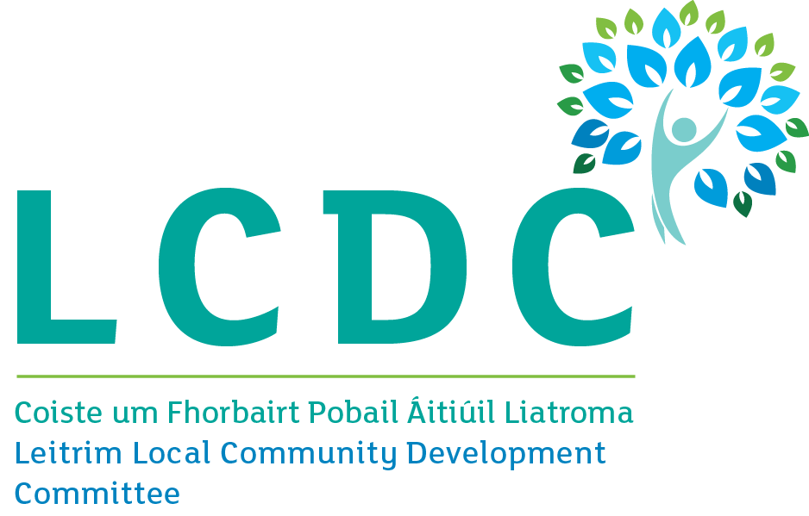

RURAL DEVELOPMENT PROGRAMME 2014-2022
EXPRESSION OF INTEREST (EOI) FORM

NOTE: This Expression of Interest (EOI) form must be completed in order to determine if your proposed project is eligible to proceed to a full application under the Transitional LEADER Programme or EURI Fund.
Note: THIS EOI IS NOT AN APPLICATION FOR LEADER FUNDING

Failure to complete this form in full will result in a delay in dealing with your Expression of Interest (EOI). All those wishing to make an application for LEADER funding must complete an EOI Form as the first step. If your EOI is eligible in principle you will be notified and you can then progress to full application stage.

Completion Guidance Notes:
- Please complete this form in full. All fields are mandatory
- This form can be downloaded or printed from Leitrim Development Company website www.ldco.ie and to Leitrim Development Company, Church Street, Drumshanbo, Co Leitrim, N41 RF24, with any additional information you feel may be of relevance to your Expression of Interest
- This form can also be completed electronically and e-mailed to Leitrim Development Company at leader@ldco.ie
- You will be informed by email if your proposed project is eligible in principle for funding and a Rural Development Officer from Leitrim Development Company will contact you to outline the next steps.
- If you require assistance in completing this form please contact the Lead Implementing Partner Leitrim Development Company on Phone: 071 964 1770, ext 25 or e-mail: leader@ldco.ie
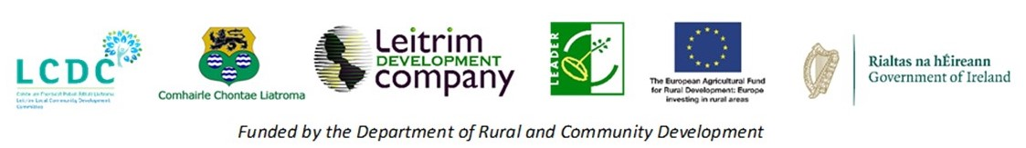

EOI Ref ID: __________________________________________

Main Programme Theme: ______________________________

LAG (IP) Officer Signature: _____________________________

Printed Name of LAG (IP) Officer: _______________________

Date form received from Promoter in LAG (IP): ____/_____/____

LAG (IP) Date Stamp
For Official Use Only:
Rural Development Programme 2014 – 2022
Expression of Interest (EOI) Form
GENERAL INFORMATION
All Fields are mandatory and must be completed
1 | Details of Project:  Please provide specific details for this project.  Project Title:  Address:  County: Eircode (mandatory):
2 | Primary Contact Details: (Please provide the primary contact details for this project)  Group/Organisation/Business Name:  Main Contact Person:  Address:  County: Postcode:  Telephone No: Mobile No:  E-mail: Website address:
3 | a) Classification of Promoter:  Cross appropriate box.  Sole Trader Community Council  Farmer (If yes, Herd No. is required below) Trust  Formalised Community/Voluntary group Partnership  Companies Limited by Guarantee Company Limited by Shares  Designated Activity Company limited by shares Private Individual  Registered Charity  Co-operative society registered under the Industrial & Provident Societies Act  Other  Note: Public bodies are not eligible for LEADER or EURI Funding
 | b) Herd Number (if family or farm family member):
4 | a) Has Promoter/Community Group received funding previously?  Please tick one  Yes No
b) If YES, please provide the following details:

Project name: Project name:
Programme applied to: Programme applied to:
Amount approved: Amount approved:
Date of Approval: Date of Approval:

Project name: Project name:
Programme applied to: Programme applied to:
Amount approved: Amount approved:
Date of Approval: Date of Approval:

5 | Proposed Project Costs:  Please provide a proposed breakdown of all elements you require funding for  Nature of Contract / Goods / Item / Element Estimated Cost (€)  Total cost of project €
6 | Sources of Funding:  Please provide details of how you intend to fund the project.  Sources of funding Estimated Cost (€)  LEADER Programme  Donation of Property  Voluntary Labour  Own resources: Cash/savings in account  Loans, investors, etc  Other: Public Funds from Non EU Source (e.g. Local Authority, Fáilte Ireland, etc.)  Total proposed cost of project
7 | What category below do you consider best fits your project? (Please tick as appropriate)  Tourism Development Broadband and ICT  Enterprise Development Social Inclusion  Village and Town Enhancement Rural Environment
8 | In relation to planning permission which of the following category best fits your project?  Planning Granted Planning Application Submitted Planning Required  Exemption Granted No Planning Required
9 | Project Description  Describe the proposed project, the main activities involved to develop it and any other parties involved.
Signed for and on behalf of the Promoter/Group:
I/We confirm that the details supplied are true and correct to the best of my/our knowledge

Print Name: ________________________________________

Signature: ______________________________________________

Date: / /

Part or all of the information you provide in this form will be held on computer and hard copy format. This information will be used for the administration of Expression of Interests and producing monitoring returns. LAG’s may share information with each other and Government departments/agencies to enable them to prevent fraudulent applications or for detecting crime and to co-ordinate processing of complementary applications. It may also be subject to meeting obligations under the Freedom of Information Act as amended. The information will be held for as long as required by the European Union under the operating rules of the RDP LEADER Programme. This policy does not affect your rights and your information will be held as prescribed under the Data Protection Acts.
The promoter/group, the DRCD, Leitrim Integrated Development Company/Leitrim County Council/Leitrim Local Community Development Committee (Leitrim LAG) are subject to the data protection and privacy laws of Ireland and the EU, in particular the Data Protection Act 2018 and Regulation (EU) 2016/679, known as the EU General Data Protection Regulation (“GDPR”). Any personal information that you provide as part of the application process will be obtained and processed in compliance with Data Protection legislation. This EOI may also be subject to meeting obligations under the Freedom of Information Act 2014. The DRCD, Leitrim Integrated Development Company/Leitrim County Council/Leitrim Local Community Development Committee (Leitrim LAG) retain the right to disclose for the purposes of a request under the Freedom of Information Act 2014 or otherwise, in connection with this EOI.
- any information supplied by the promoter/group to the DRCD, Leitrim Integrated Development Company/Leitrim County Council/Leitrim Local Community Development Committee (Leitrim LAG);
- any relevant data gathered by the DRCD, Leitrim Integrated Development Company/Leitrim County Council/Leitrim Local Community Development Committee (Leitrim LAG); Name in processing this EOI, except where the information is considered to be personal or commercially sensitive.

